Assignment 2
1)a)
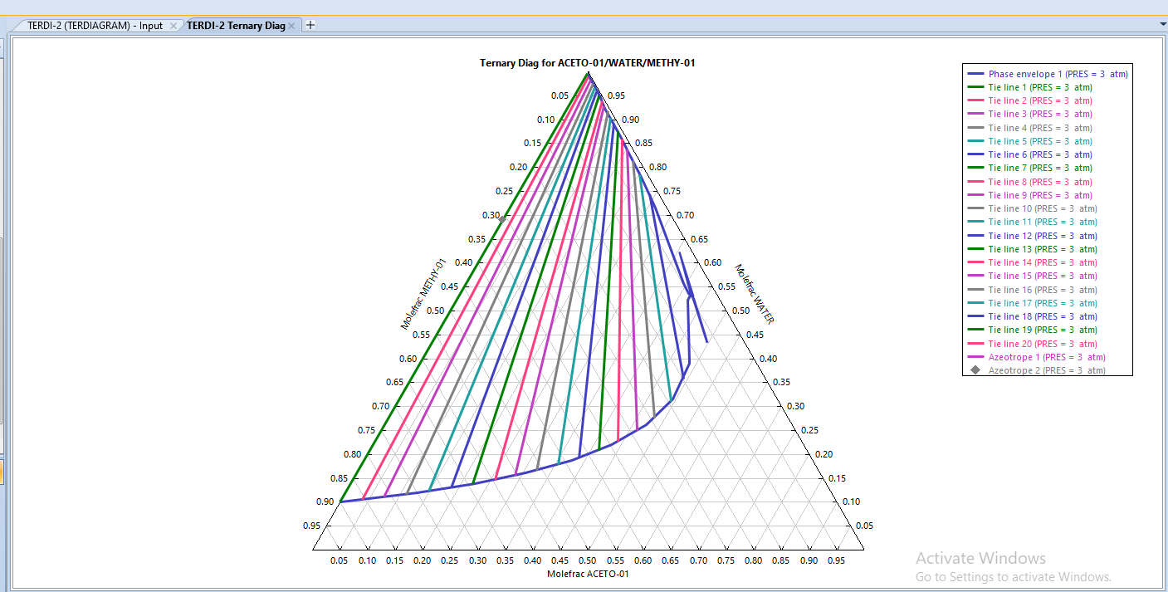

So for given composition of streams the final mixed stream should correspond to the following mole fractions:
0.5 MIBK
0.45 H₂O
0.05 Acetone

This corresponds to the third tie line.

Therefore from the results table,
- Concentration of Acetone in Extract Phase(MIBK) = 0.0756339
- Concentration of Acetone in Raffinate(water as solvent) = 0.0135143
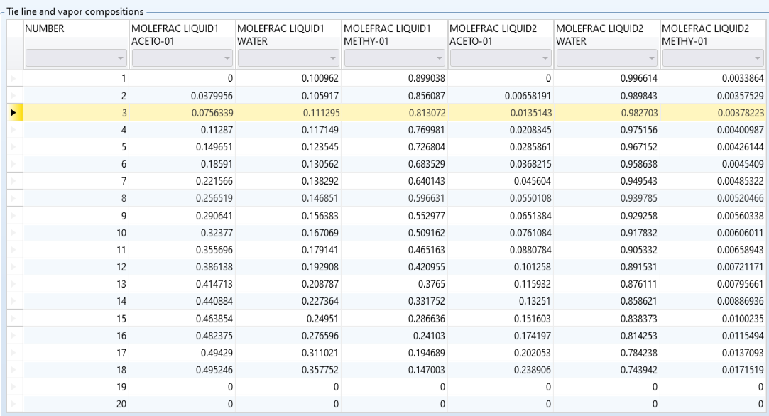

b)
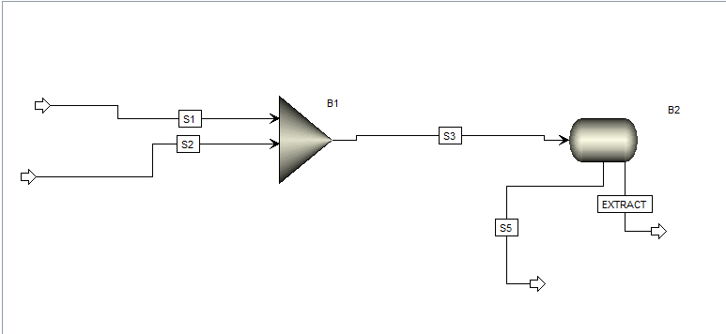

Stream | Flow Rate(kmol/hr) | Mole Fraction of Acetone | Mole Fraction of MIBK | Mole Fraction of Water
Extract | 122.252832 | 0.0734646 | 0.815580 | 0.110956
Raffinate | 77.747168 | 0.0131033 | 0.983127 | 0.00376985

Fraction of extracted Acetone = (Moles of Acetone in Extract)/(Total moles of Acetone)
=(8.9812)/10 = 0.8981= 89.81%
c) Fraction of extracted Acetone = (Sum of moles of Acetone in the Extracts)/(Total moles of Acetone)
= (8.06234129243946+6.02573533306934)/10
= 0.96393 = 96.393%

Stream | Total Flow rate(kmol/hr) | Acetone |  | Water |  | MIBK
 |  | Flow rate(kmol/hr) | Fraction | Flow rate(kmol/hr) | Fraction | Flow rate(kmol/hr) | Fraction
Extract - 1 | 65.503 | 8.0623 | 0.1231 | 7.7854 | 0.1188 | 49.6555 | 0.75806
Raffinate -1 | 84.497 | 1.9377 | 0.02293 | 82.2145 | 0.9730 | 0.3445 | 0.0040769
Extract - 2 | 57.677 | 1.5769 | 0.02734 | 6.0257 | 0.1045 | 50.0741 | 0.8682
Raffinate - 2 | 76.820 | 0.361 | 0.00470 | 76.1888 | 0.9918 | 0.27044 | 0.00352

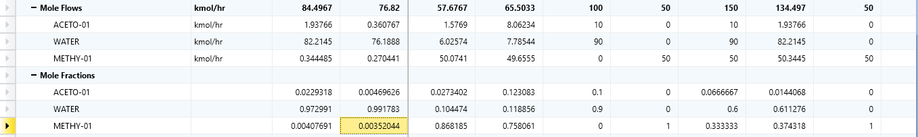
d) From the percentage extraction we can clearly see that TWO STAGE CROSS CURRENT EXTRACTION PROCESS IS MORE EFFICIENT because more Acetone is separated in it( greater percentage extraction).
Reasons for improved efficiency:
- Raffinate stream which still contains acetone is reused in one more extraction process using a pure solvent.
- Given that a constant fraction of the solute is extracted each time we add the same amount of solvent, if we add an infinitesimal amount of the solvent each time and the number of stages goes to infinity, we get a theoretical 100% extraction. Because even if the amount extracted each time is small, since the number of extractions is high we can completely extract it.
- So practically as we increase the number of stages we get a better percentage extraction.

2) Reaction Equation: N₂+3H₂ --> 2 NH₃

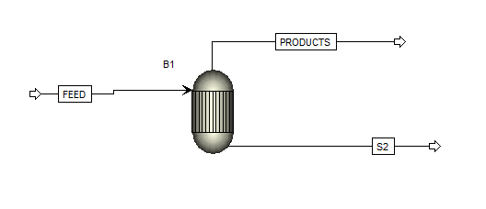

Conditions : 500C, 150 atm

INPUT MOLE FRACTIONS |  |  | OUTPUT MOLE FRACTIONS
N₂ | H₂ | NH₃ | N₂ | H₂ | NH₃
0.5 | 0.5 | 0 | 0.4999 | 0.3904 | 0.1096

Equilibrium conversion = (Ammonia formed)/(Max number of moles of Ammonia that can form by stoichiometry)
= 0.2964 = 29.64%

Similarly for each case using the molar flow rate we can evaluate the conversion.
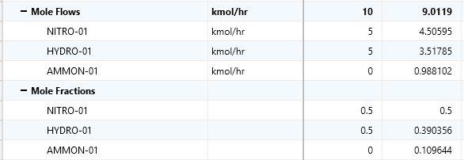

a)
P is maintained constant at 150 atm.
TEMPERATURE(Celsius) | CONVERSION
400 | 0.5588
450 | 0.4159
500 | 0.2964
550 | 0.2072
600 | 0.1447

As we increase Temperature, Conversion decreases. This is in accordance with the Le Chatelier’s principle – since this reaction is EXOTHERMIC, increase in temperature will reduce the amount of product formed.
b) T is maintained constant at 500 degree Celsius
PRESSURE(atm) | CONVERSION
50 | 0.1272
100 | 0.2219
150 | 0.2964
200 | 0.3574

NUMBER OF MOLES OF GASEOUS REACTANTS IS MORE THAN THAT OF NUMBER OF MOLES GASEOUS PRODUCTS per mole of the reaction, so when the system volume is less product formation is favoured. This implies that HIGHER PRESSURE favours PRODUCT FORMATION in accordance with Le Chatelier’s principle.

3)
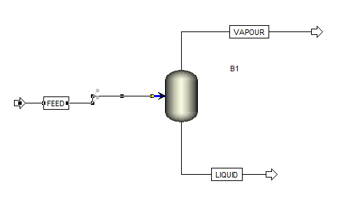

a) ISOTHERMAL FLASH:
Feed at 30 C and 1 atm.
Flash drum operating at 61 C and 1 atm.
Vapour and Liquid streams at 60 C and 1 atm.

 | COMPOSITION OF LIQUID PHASE
MOLE  FRACTIONS | n-Hexane | ethanol | methyl-cyclopentane | Benzene
MOLE  FRACTIONS | 0.12969 | 0.60723 | 0.12372 | 0.13936

 | COMPOSITION OF VAPOUR PHASE
MOLE  FRACTIONS | n-Hexane | ethanol | methyl-cyclopentane | Benzene
MOLE  FRACTIONS | 0.26004 | 0.38271 | 0.20636 | 0.15089

Vapour Fraction = (number of moles of vapour)/(total number of moles)
= 0.922978
Since this is a constant pressure process, Energy change = Enthalpy change
 | FEED | LIQUID | VAPOUR
Molar Enthalpy  (kJ/mol) | -179.3070 | -198.3955 | -139.2686
No. of Moles | 1 | 0.07702 | 0.9229

so energy change = 35.4955 kJ/mol
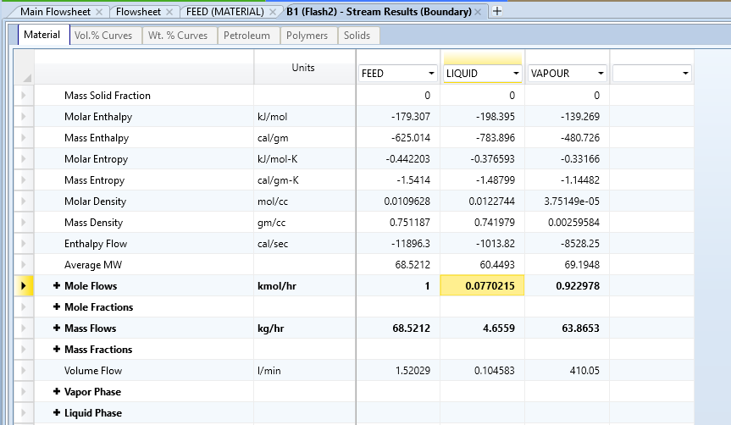

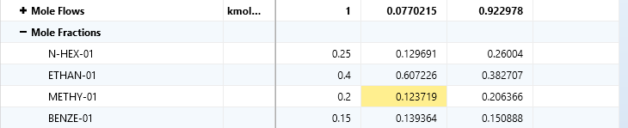

b)ADIABATIC FLASH:

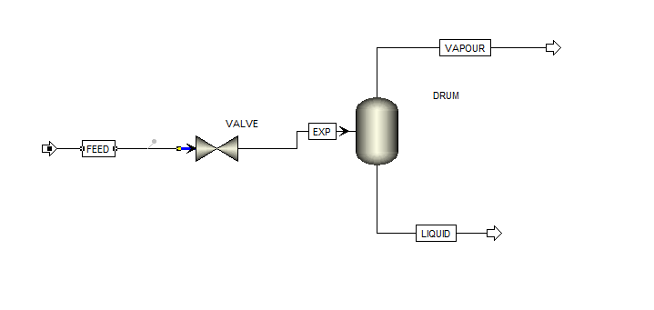
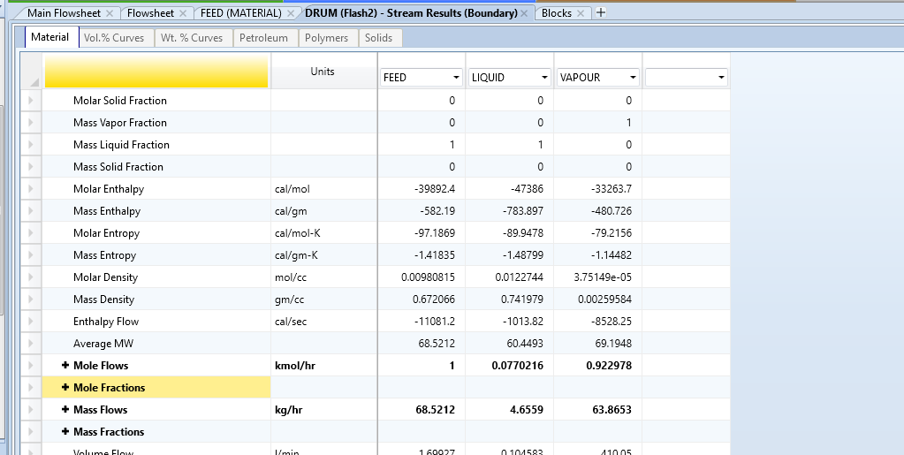

- Feed at 100 C and 30 atm expanded through an isenthalpic valve to 1 atm pressure.
- Flash drum operating at 61 C and 1 atm.
- Both the vapour and liquid streams are at 61 C and 1 atm.

 | COMPOSITION OF LIQUID PHASE
MOLE  FRACTIONS | n-Hexane | ethanol | methyl-cyclopentane | Benzene
MOLE  FRACTIONS | 0.12969 | 0.60723 | 0.12372 | 0.13936

 | COMPOSITION OF VAPOUR PHASE
MOLE  FRACTIONS | n-Hexane | ethanol | methyl-cyclopentane | Benzene
MOLE  FRACTIONS | 0.26004 | 0.38271 | 0.20636 | 0.15089

Vapour Fraction = (number of moles of vapour)/(total number of moles)
= 0.922978

